PUBLIC NOTICE

Please take notice that members of the Evans City Council will be attending the City Attorney job description and recruitment process planning meeting event on Tuesday, January 20, 2026 beginning at 5:00 p.m. in the Executive Board Room at the Evans Community Complex, 1100 37th Street, Evans, CO 80620.

At least three members of the City Council will be attending this meeting.
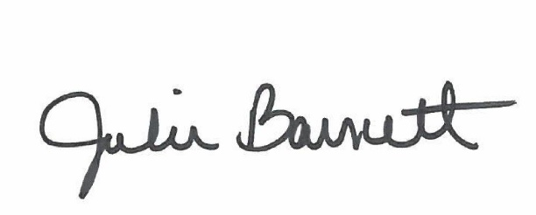

______________________________________
Julie Barnett, City Clerk

Posted: January 16, 2026

