PUBLIC NOTICE

Please take notice that members of the Evans City Council will be attending the Mayor’s Virtual Town Hall on Wednesday, September 17, 2025, 2025 beginning at 6:00 p.m.

You are invited to join the meeting through Zoom https://us02web.zoom.us/j/84696141965

At least three members of the City Council expressed interest in attending this meeting.
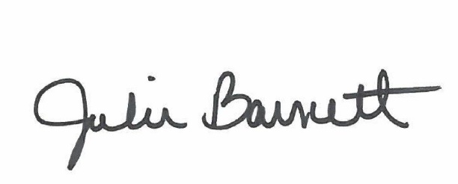

______________________________________
Julie Barnett, City Clerk

Posted: September 16, 2025

