PUBLIC NOTICE

SPECIAL WORK SESSION AND STRATEGIC RETREAT

Please take notice that members of the Evans City Council will be attending a Special Work Session Strategic Retreat on Tuesday, February 24, 2026 beginning at 5:00 P.M. in the Board Room at the Riverside Library and Cultural Center, 3700 Golden Street, Evans, CO 80620.

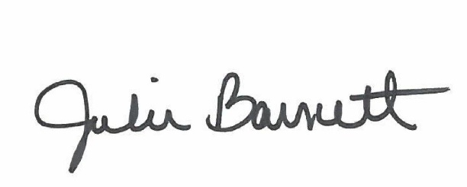

______________________________________
Julie Barnett, City Clerk

Posted: February 20, 2026

