PUBLIC NOTICE

Please take notice that members of the Evans City Council will be attending the City Attorney job interviews event on Friday, March 6, 2026 beginning at 10:00 a.m. in the Council Chambers at the Evans Community Complex, 1100 37th Street, Evans, CO 80620.

At least three members of the City Council will be attending this meeting.
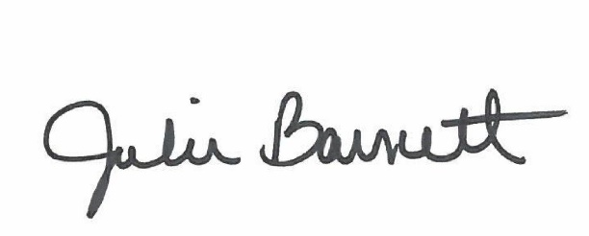

______________________________________
Julie Barnett, City Clerk
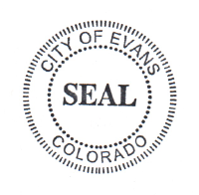
Posted: March 4, 2026

