PUBLIC NOTICE

Please take notice that members of the Evans City Council will conduct a ribbon cutting ceremony at the new Evans Police Department on Tuesday, October 6, 2026 beginning at 5:30 p.m. The ceremony will take place at 3737 St. Vrain Street, Evans, CO 80620.

At least three members of the City Council will be attending this meeting.
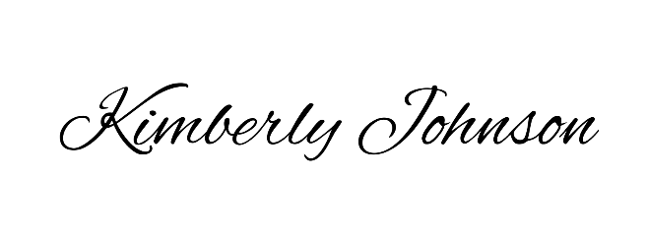

______________________________________
Kimberly Johnson, Deputy City Clerk

Posted: October 2, 2026

